Ben Clark

TGIS 504

Lab 5

Part 1:

For the first part of this lab I decided to create a mobile application using Xcode and Swift. This is compatible with iOS. The app will render a map of the users location and give a route to a specific place. For my example I used New Orleans as the destination (because AAG!) and since I was using the iOS emulator for desktop the default user location was set as Apple Headquarters. I followed a few tutorials that I found and were shared on YouTube. Below is the link to the output code and a screen shot of the final application.

<https://github.com/clarkbennett/TGIS504-Lab5/blob/master/ViewController5a.swift>

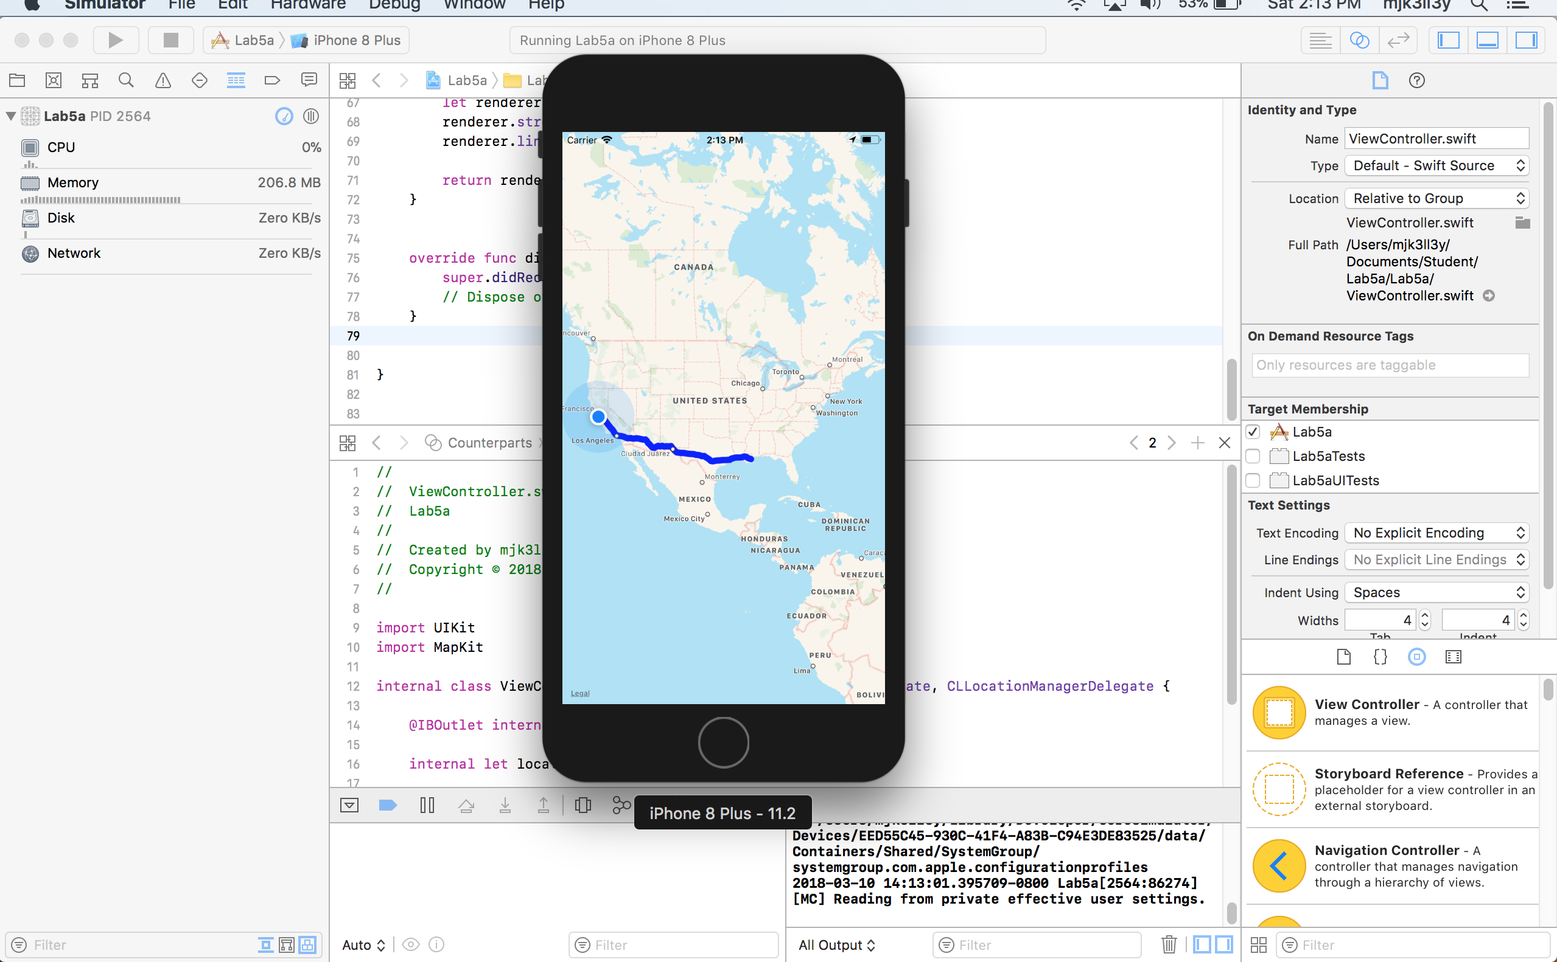

Part 2:

For this part of the lab I decided to customize a Mapbox Maps SDK for iOS example using Xcode and Swift. This part required a lot of stumbling through online documentation and tutorials. Mapbox provided their own tutorial that helped considerably but was missing a couple key steps to make the process seamless. The example I chose was adding a marker and annotation to a Mapbox map background. Below is a link to the resulting code and a few screen shots during the process.

<https://github.com/clarkbennett/TGIS504-Lab5/blob/master/ViewController5b.swift>

In order to use the Mapbox framework with Xcode you need to download it and incorporate it into your project. If you follow their tutorial you can mostly figure it out. <https://www.mapbox.com/install/ios/download/>

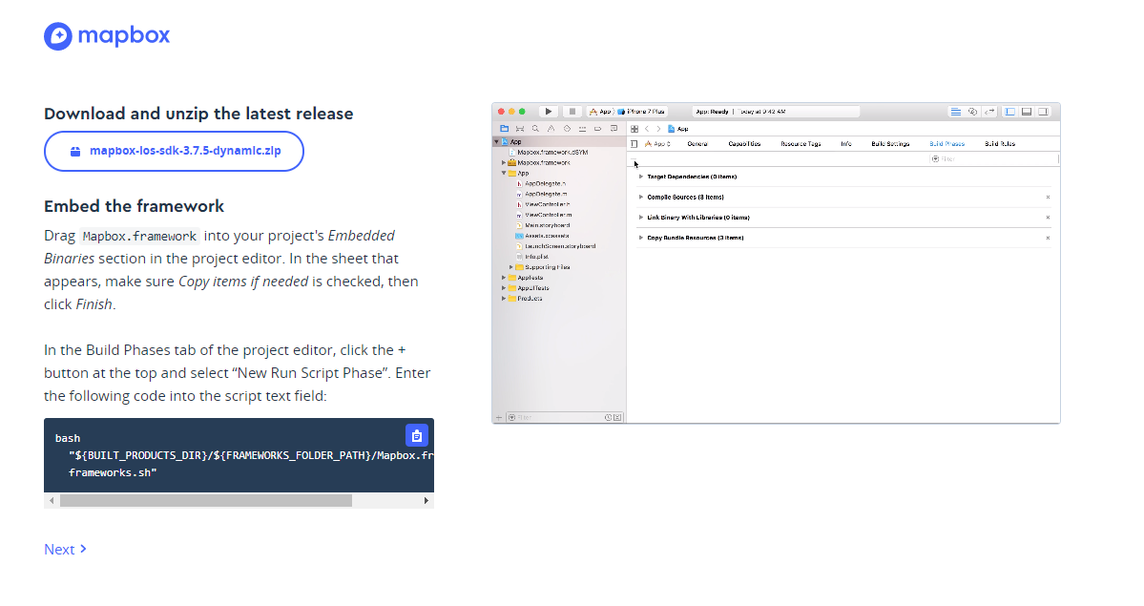

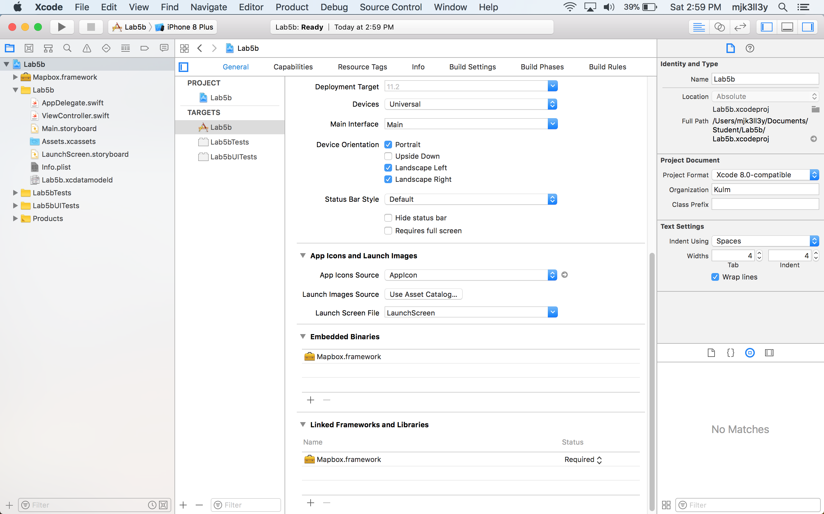

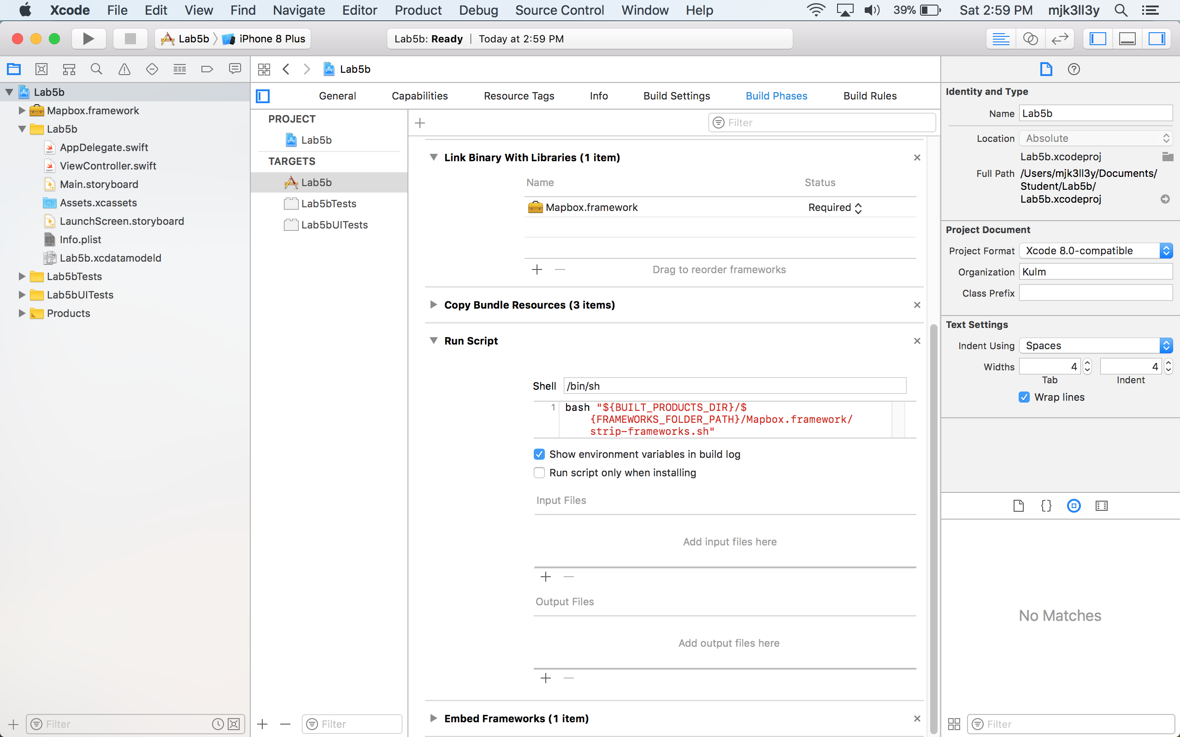

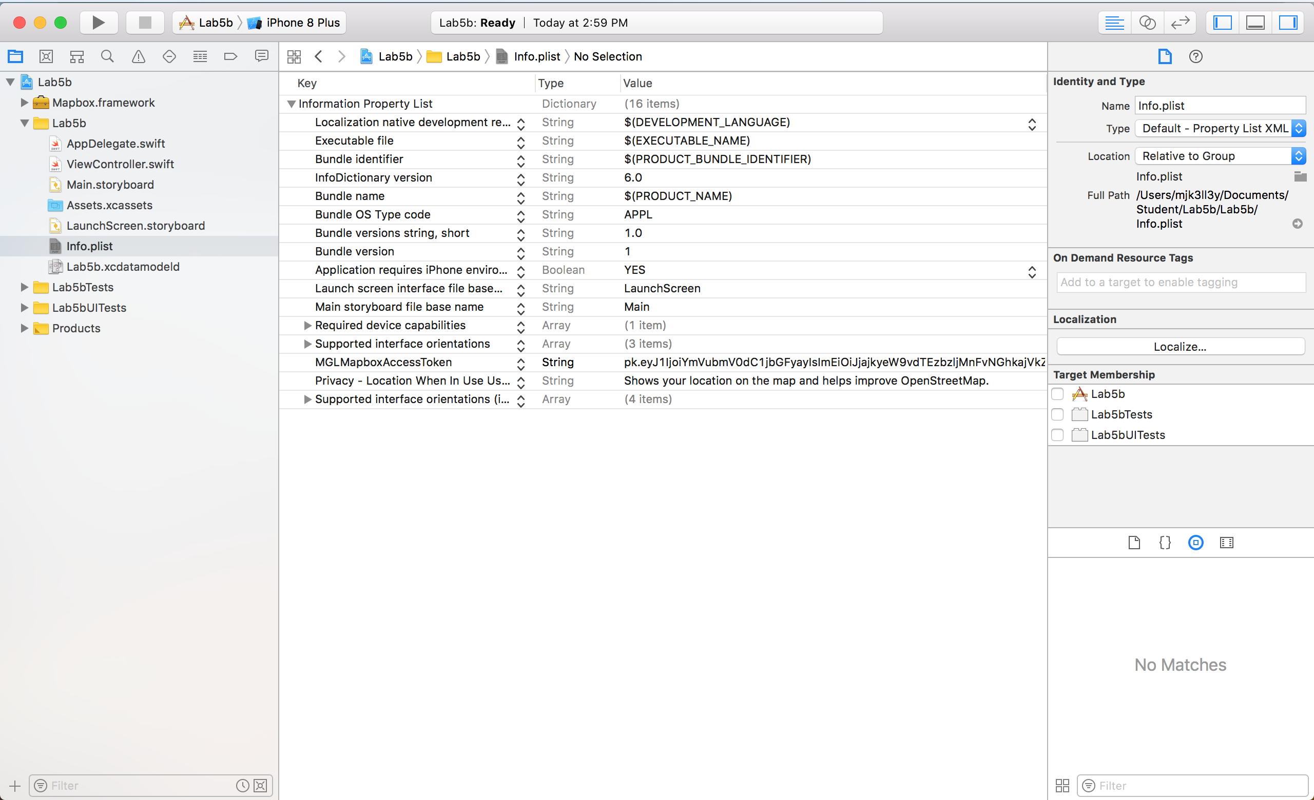

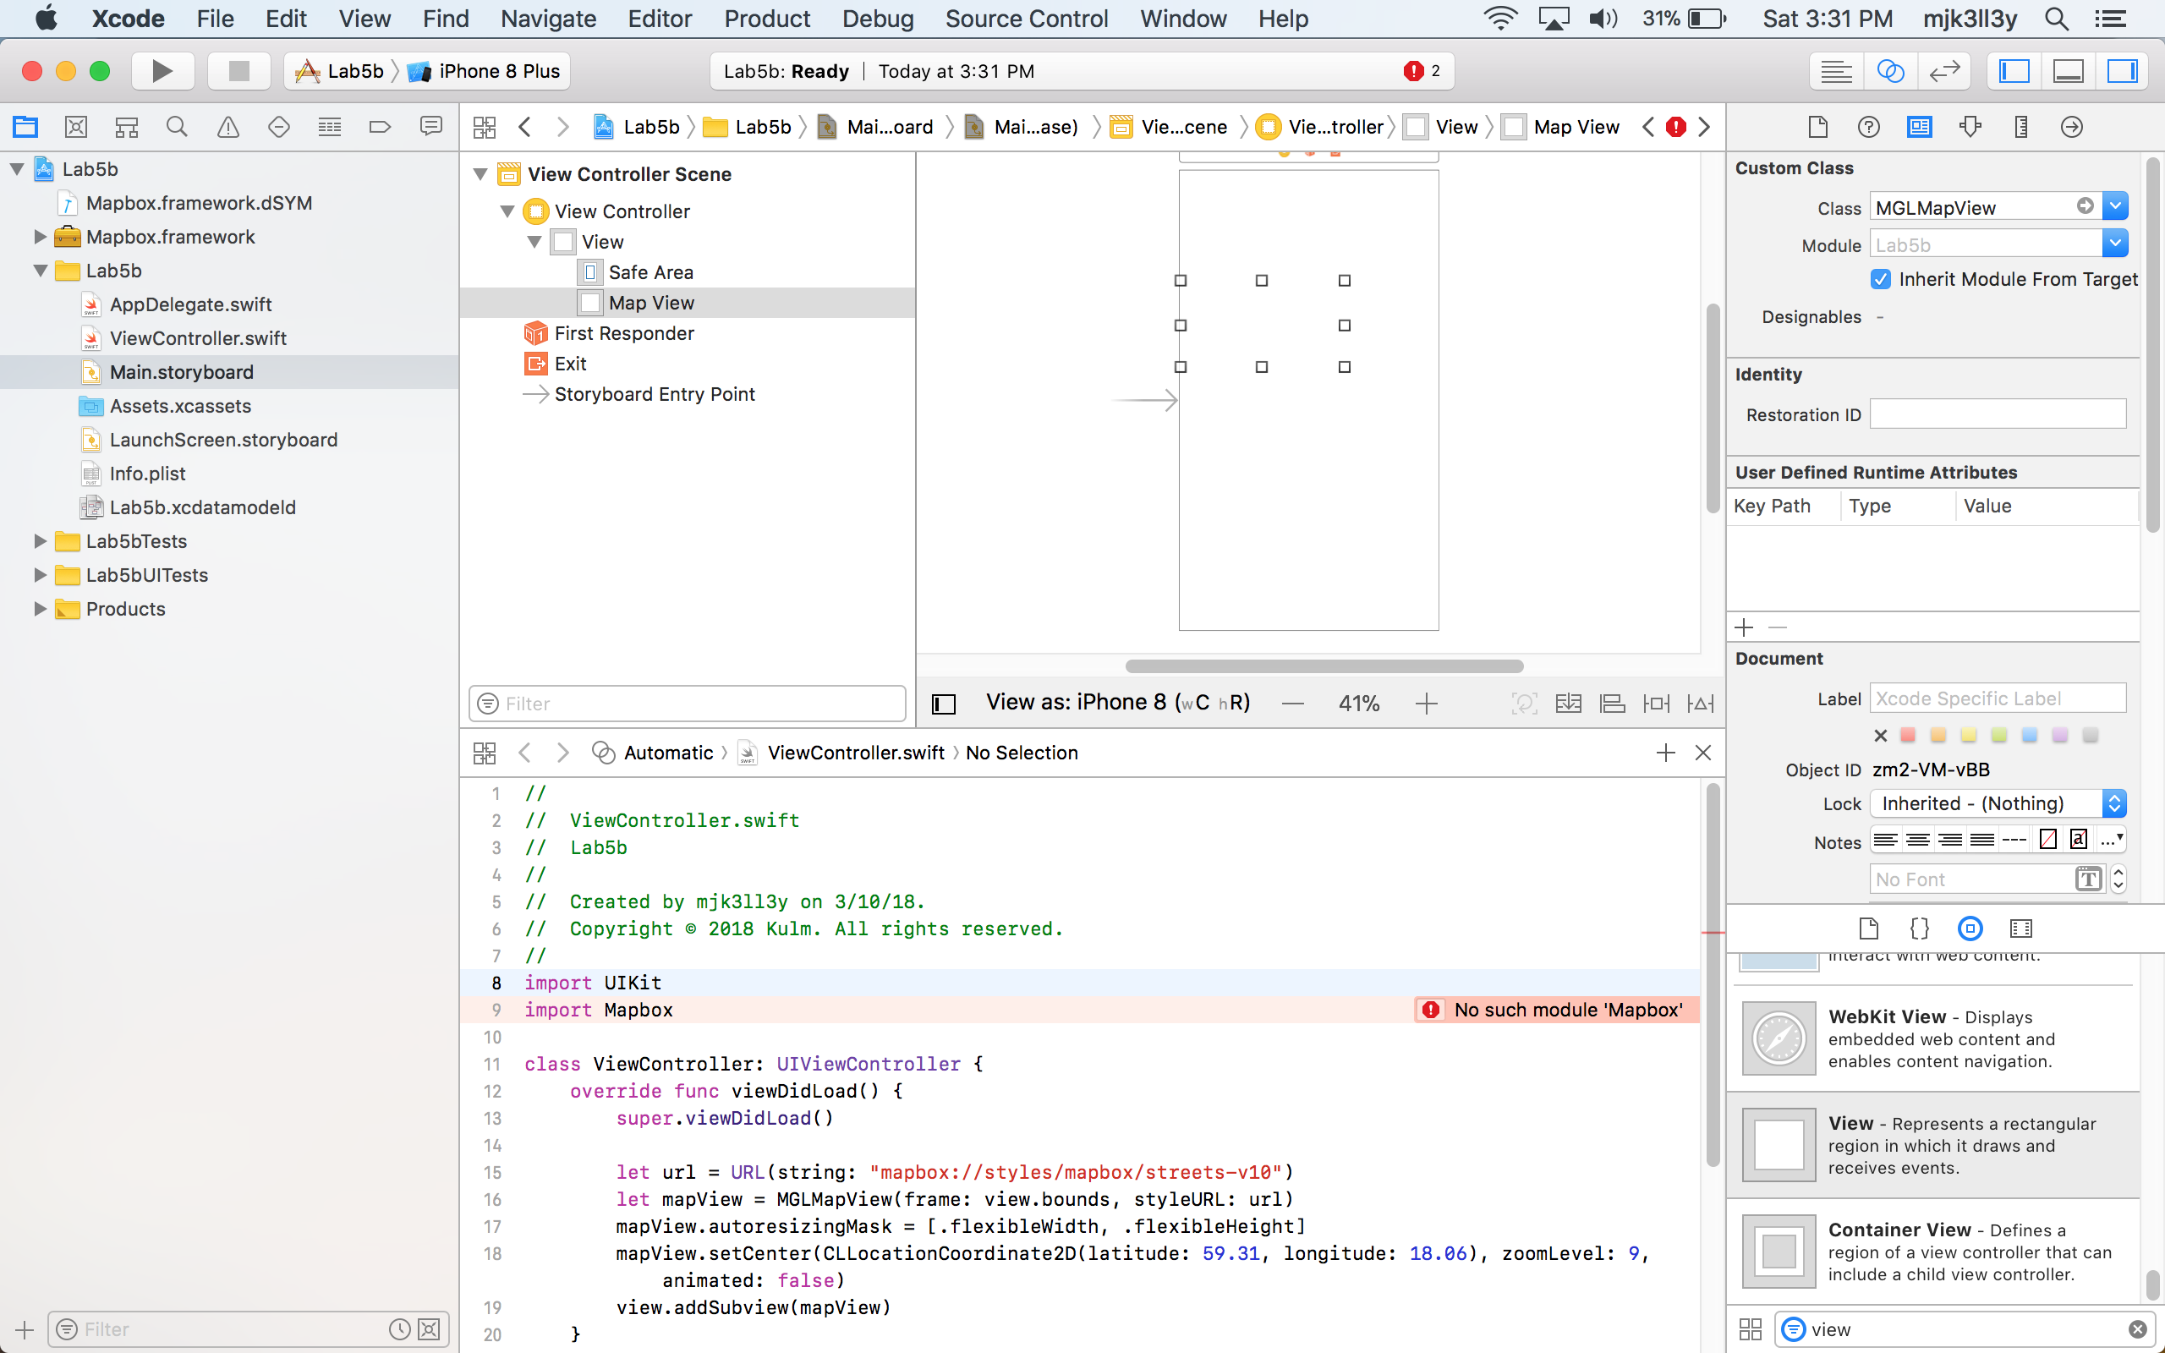



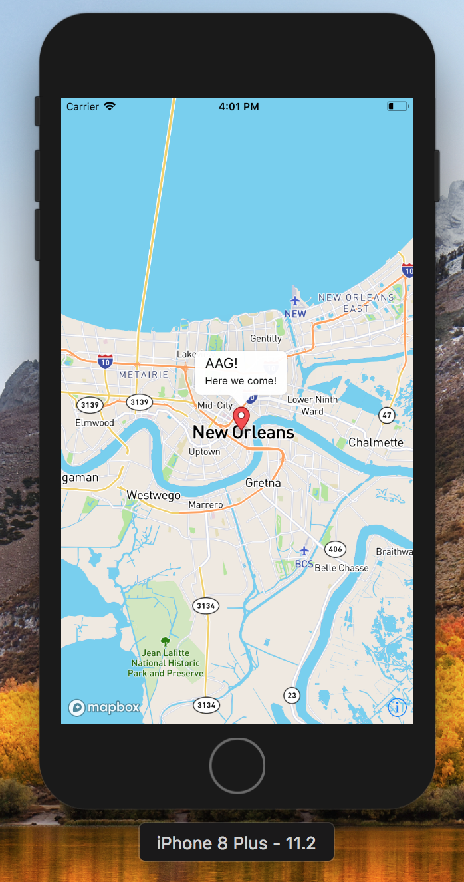

Part 3: Floyd needs to hurry his ass up and finish this part